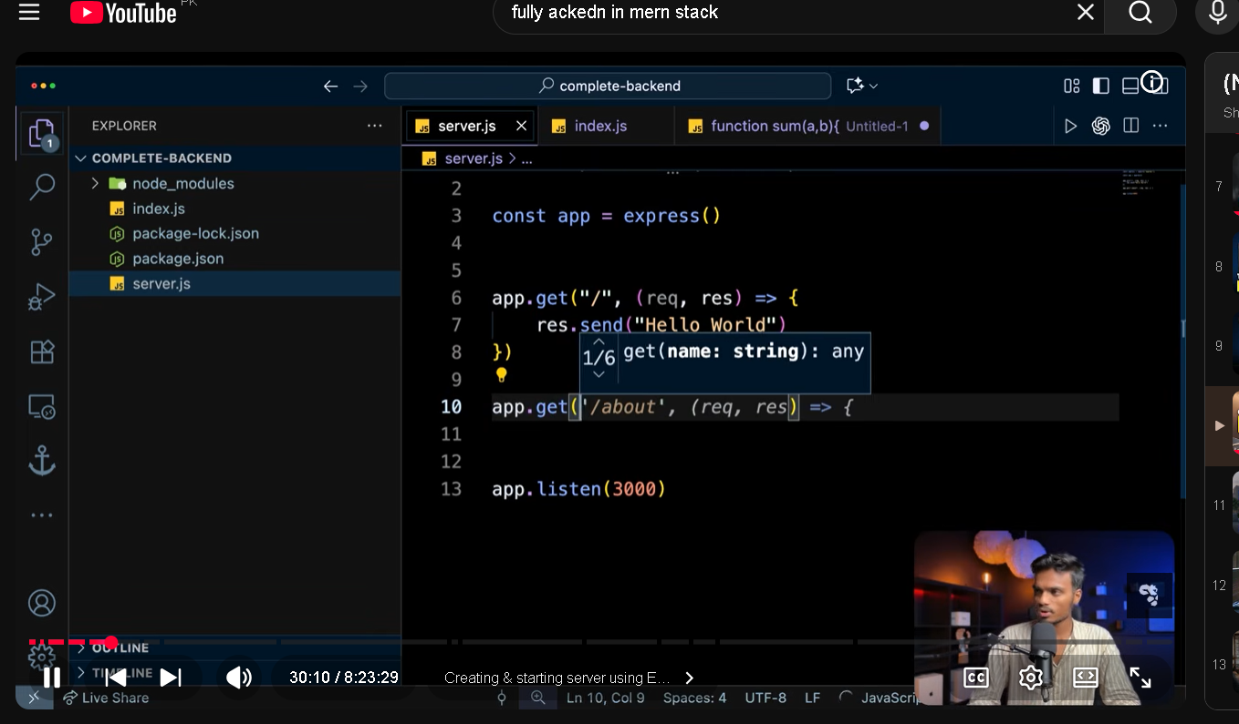
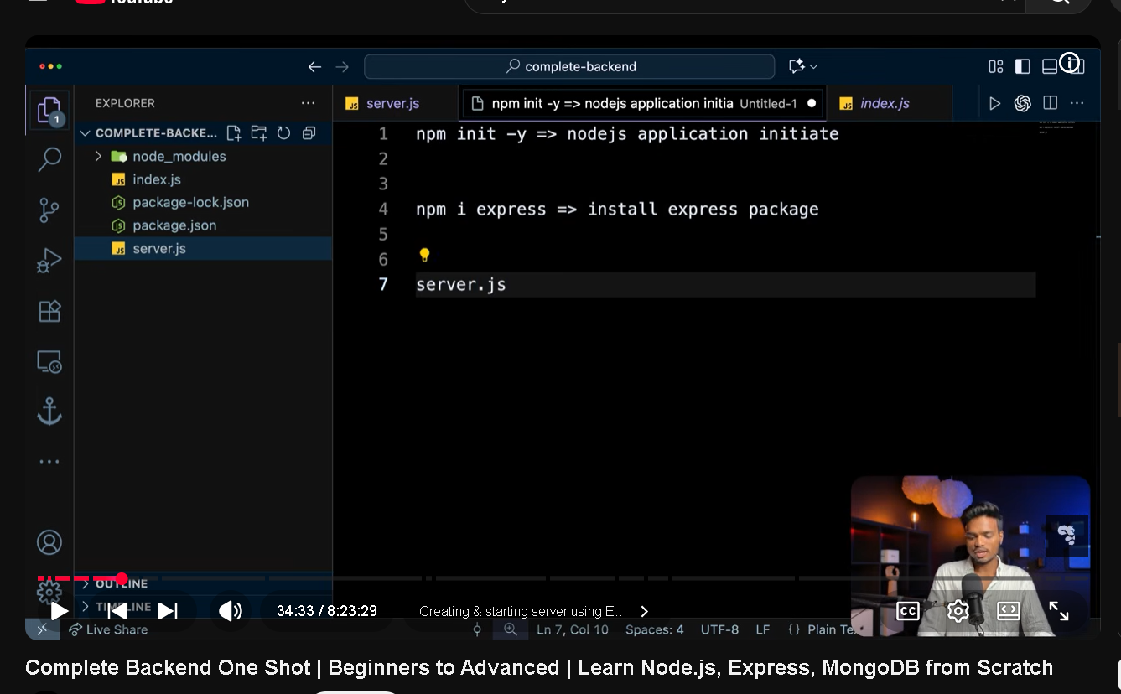
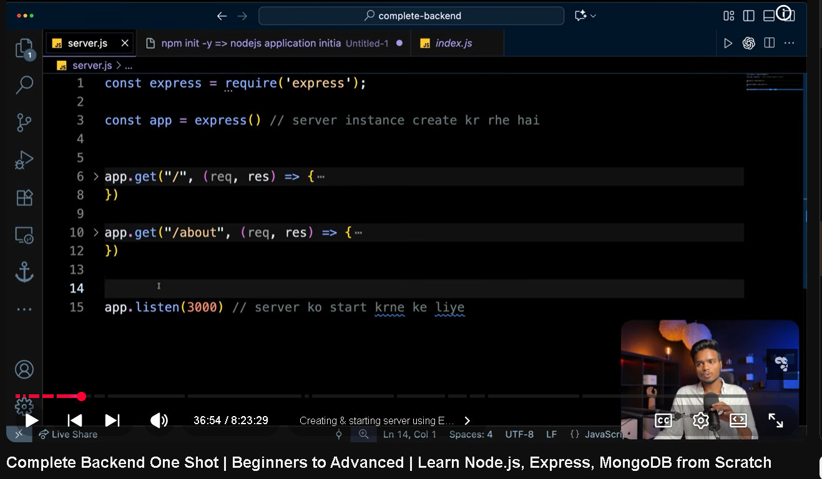
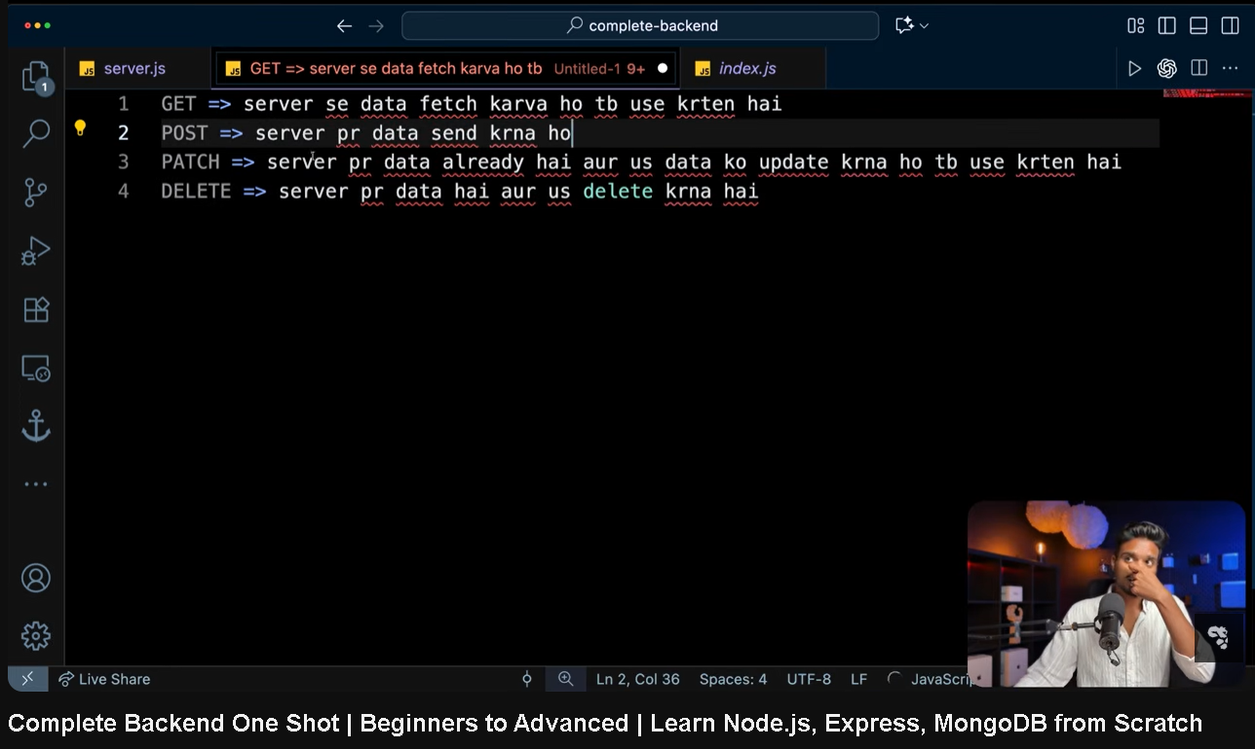
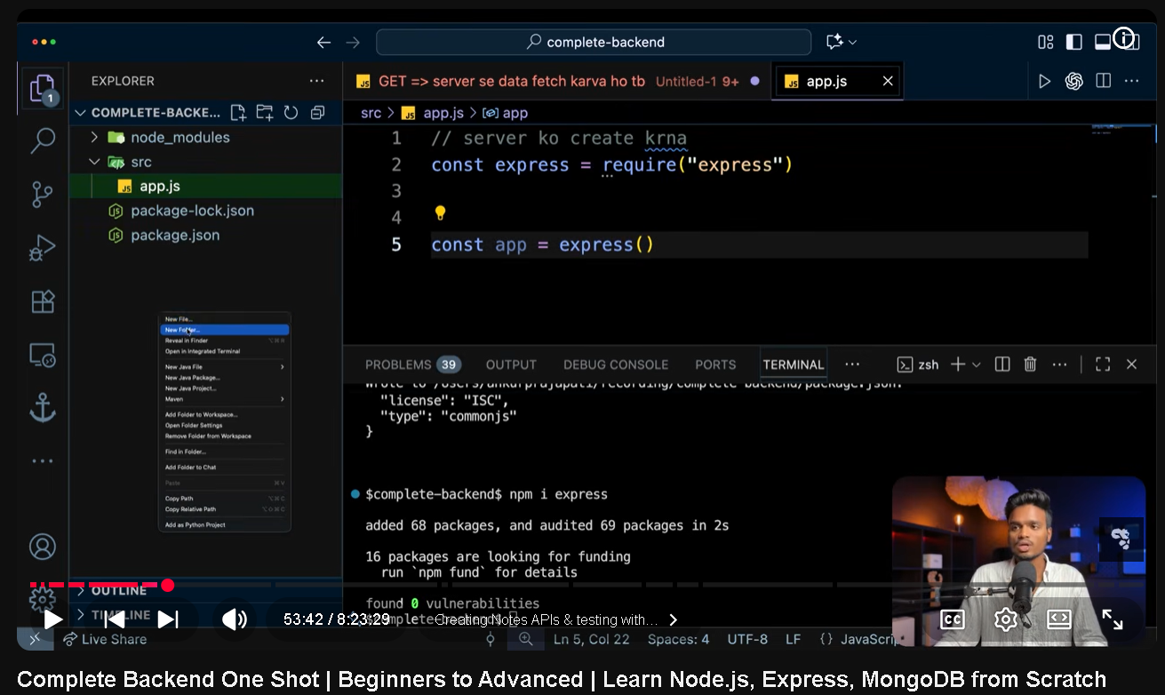
Server banta app.js ma hai likein start kisi or file mai hota hai
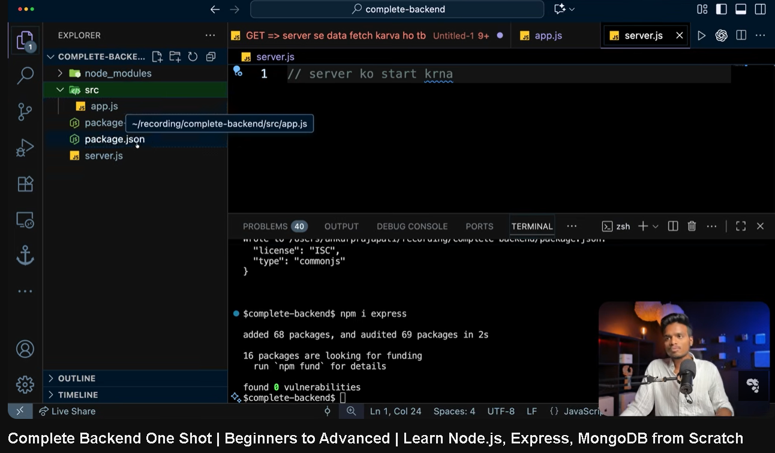
Server.js start krti hai server
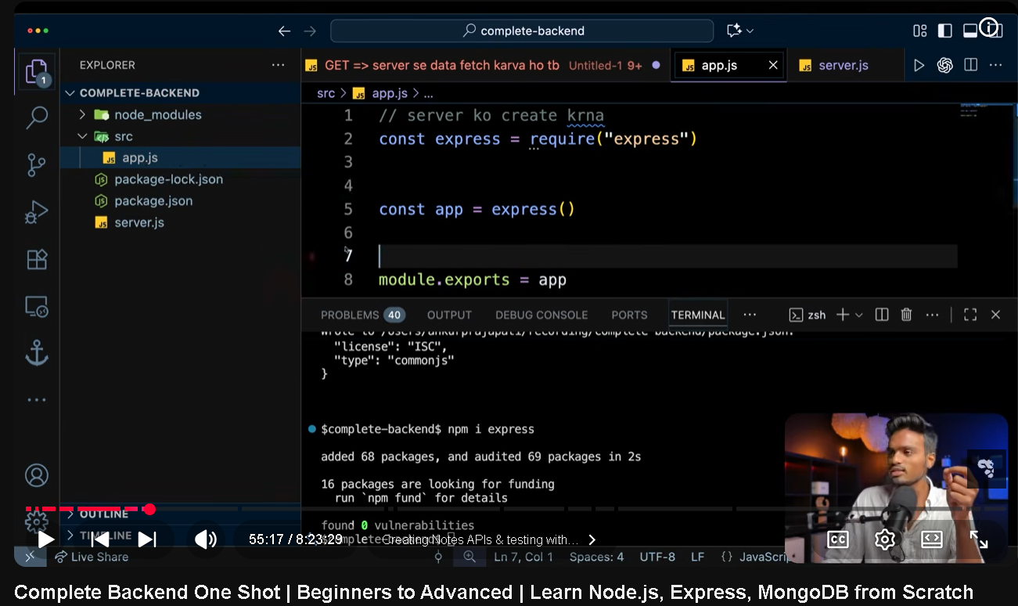
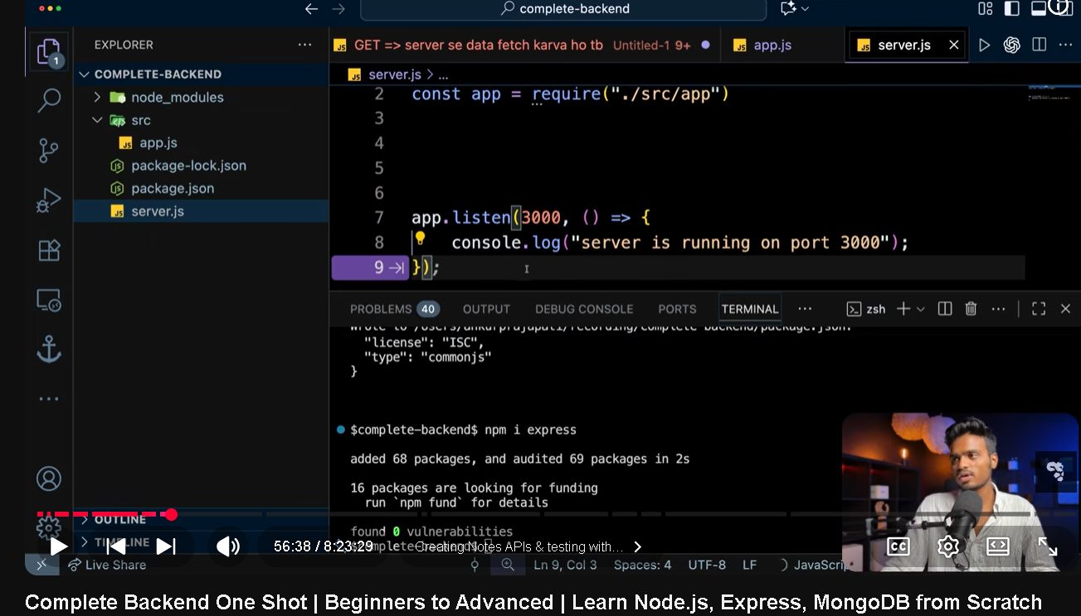
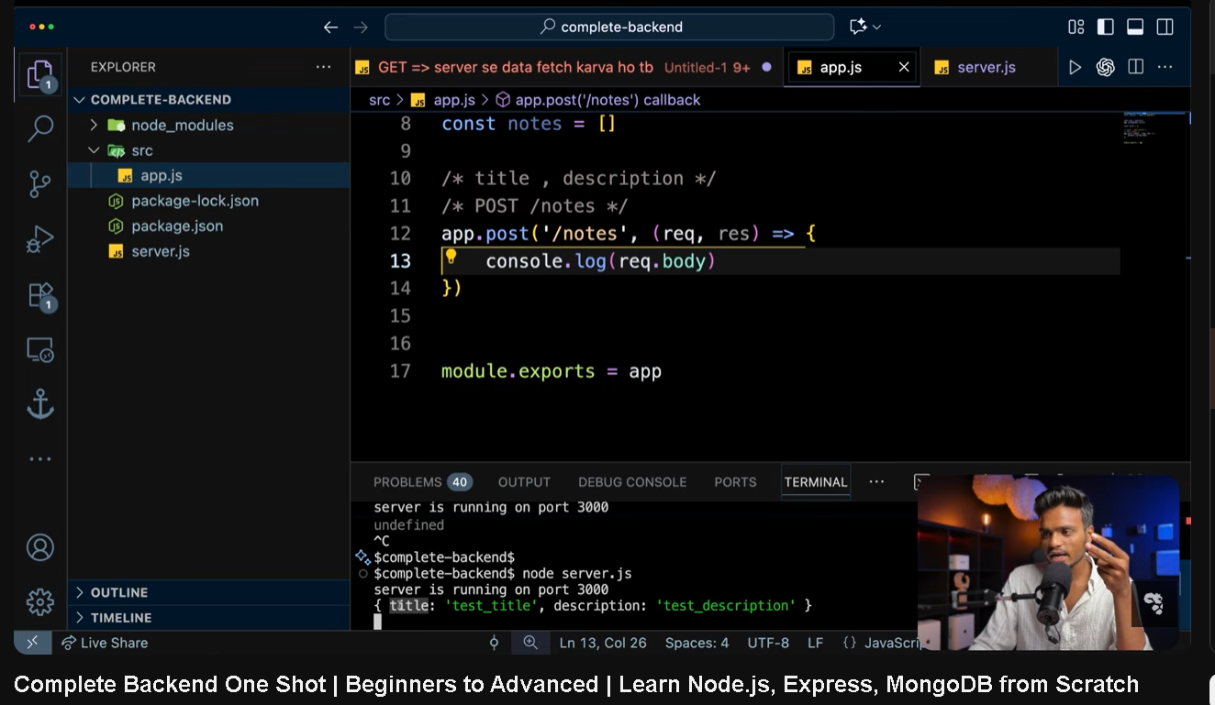
front end sai dat backed mai bhejna ho to body mai gata hai express.json aik middle ware use krtay hai dat front ed sia go arah hai usay read kr sakay warna express read nhi kr sakta
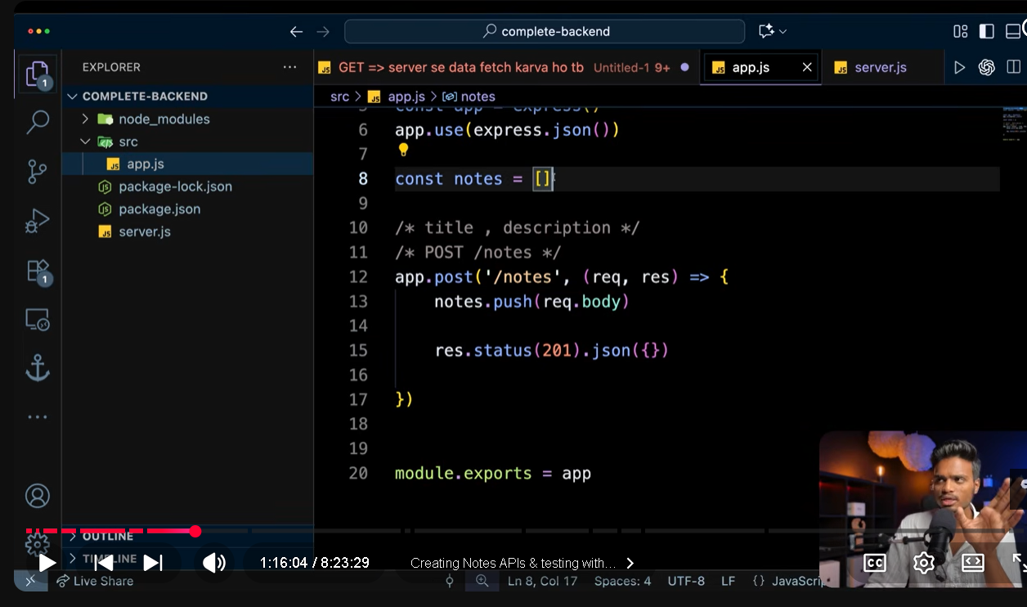
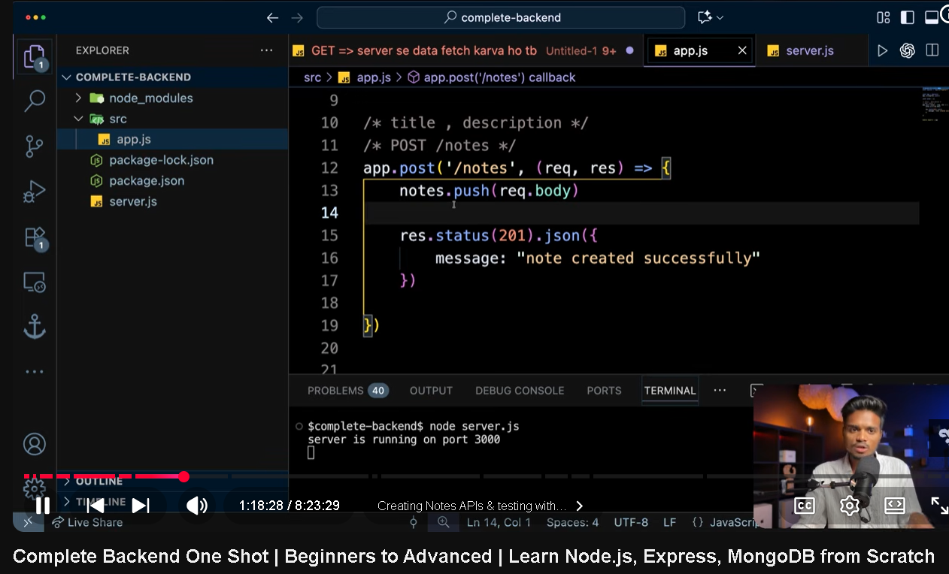
Server sia response ya data agr front edn pai bhajan ho to res.json json fromat mai bhejtay hai
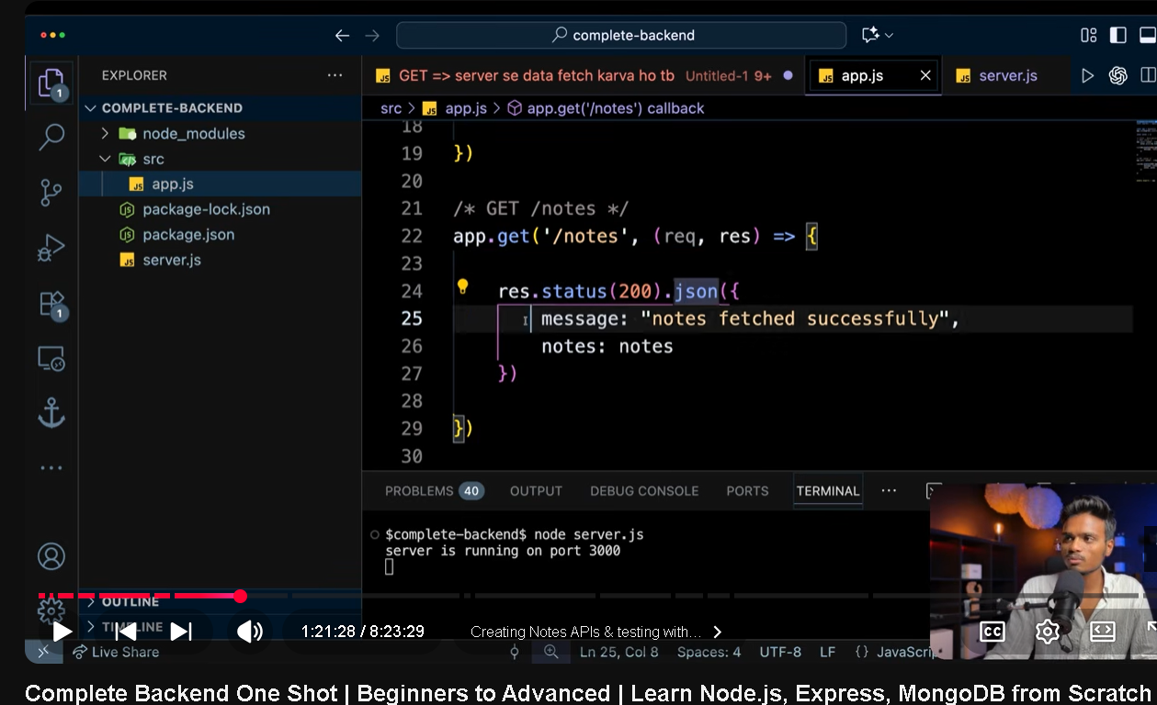
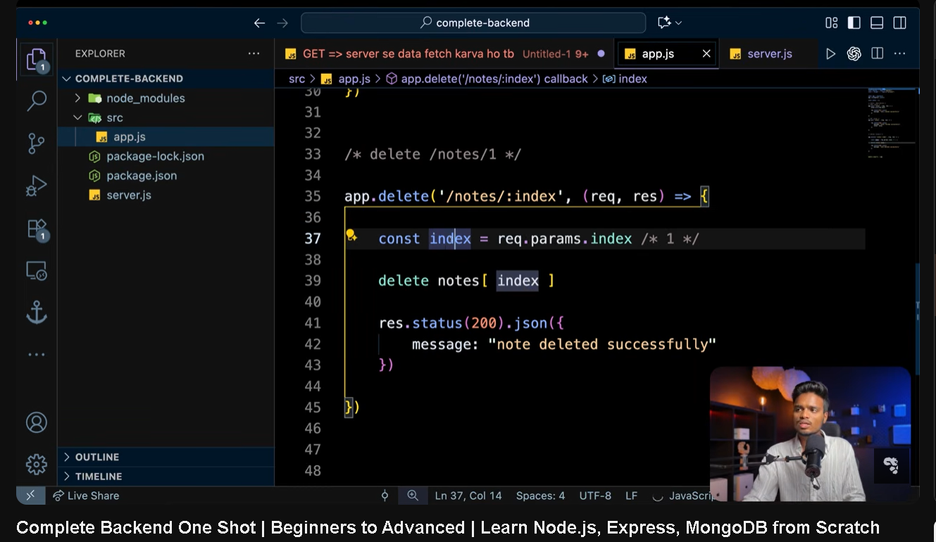
:colon wala variavle route mai ham dynamic bna daiaty hai gis variable ro dynamic bnana ho us kai sath colon laga daitay hai
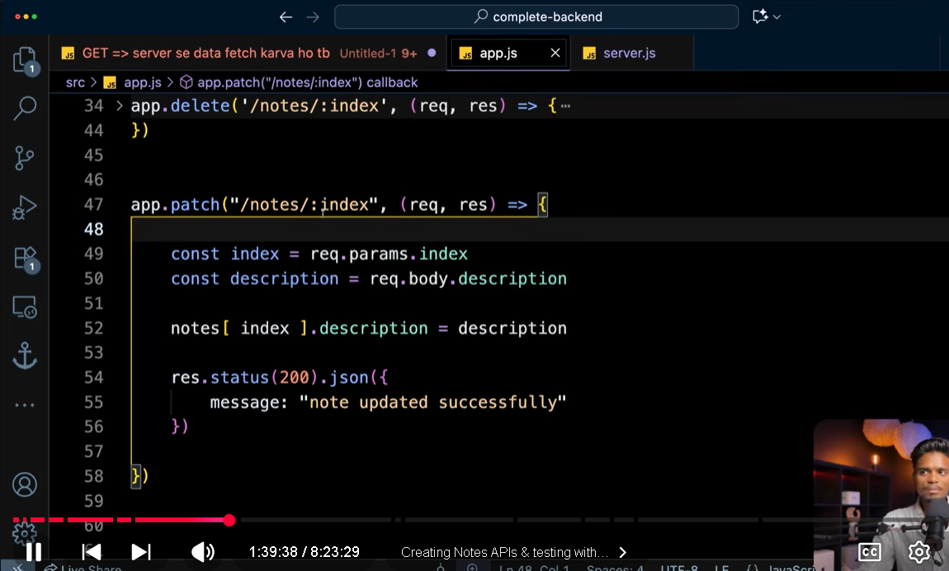
mongo db atlas mai ham clustrs create krtay hai or ohir apni local machine ko us cluster sai connect krtay hai locol address ham apnay deivce ak nhi daitay zeros likh daitay hai kiu kai hamara device ka wifi cnage ho sakta hai is liye ham zeros enter kr daitay hai mongo db atlas ai
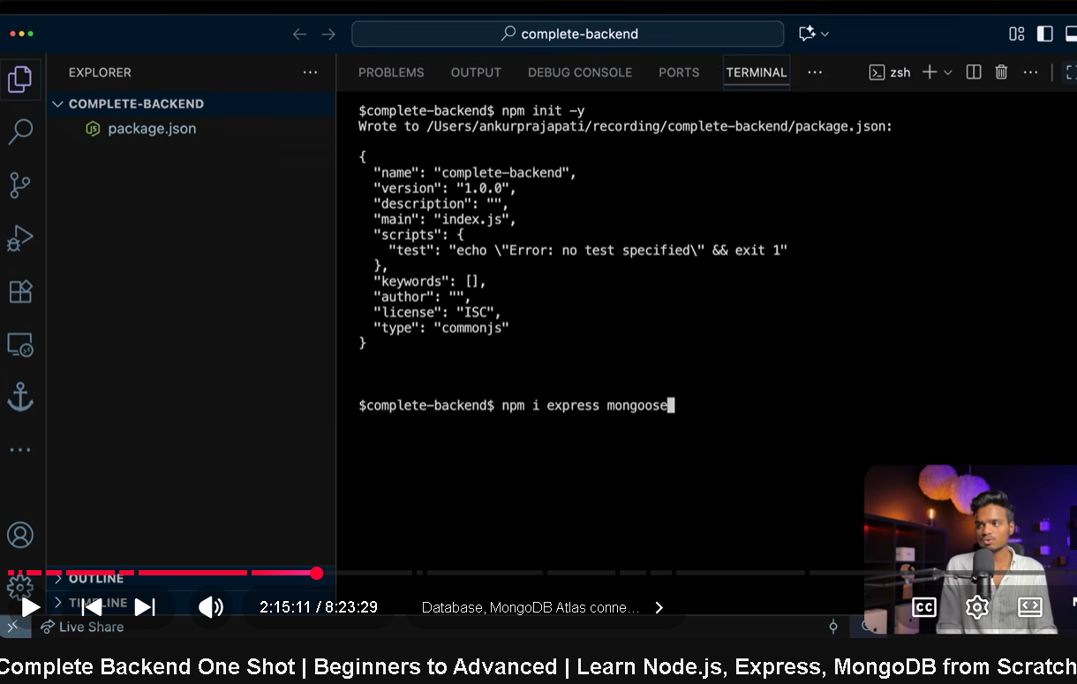
express server create krnay kai liye use hota hau or bohot features provide krta hai gaisay middle ware express.json cookie parser or bhi bohot sai
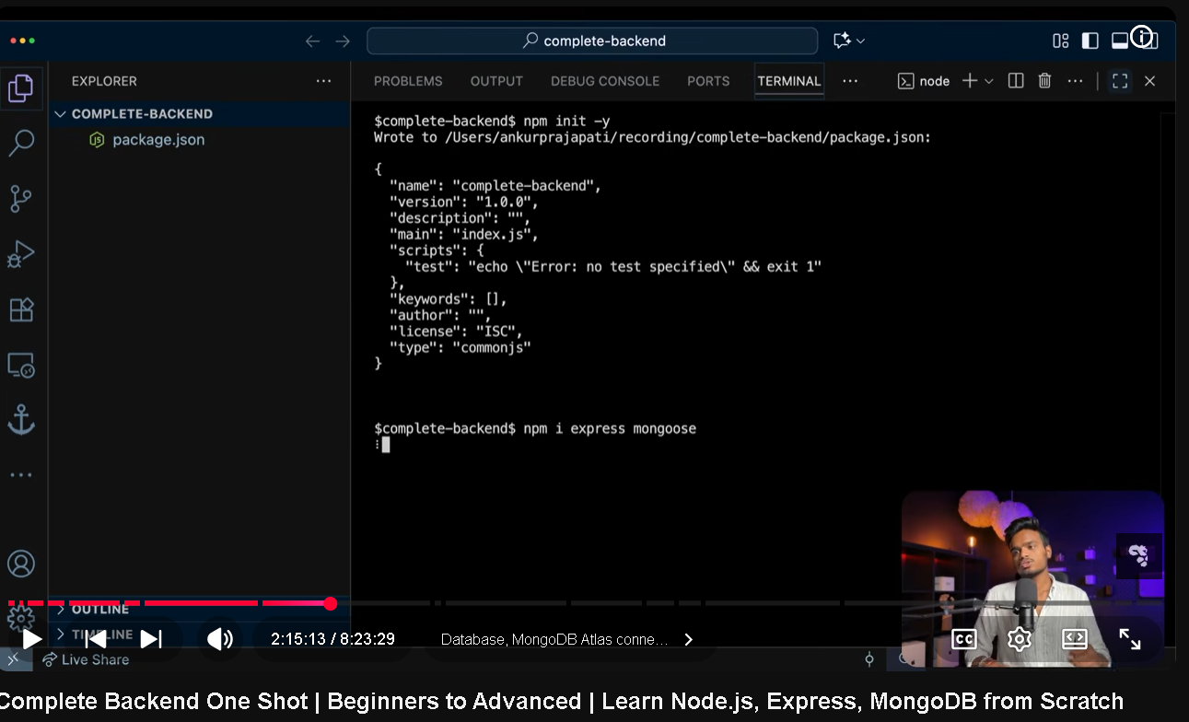
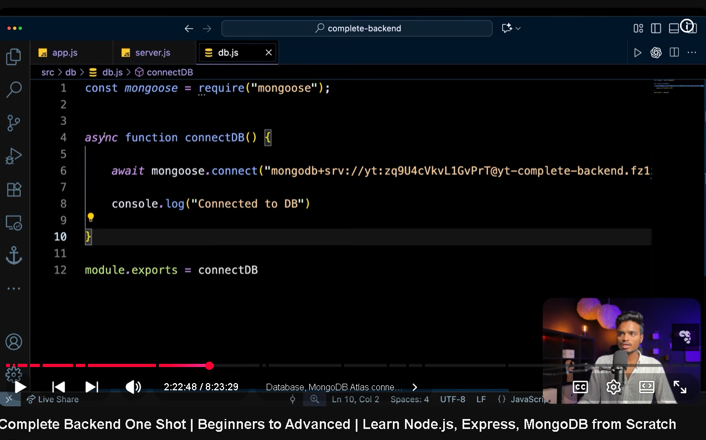

server ko databse sai connect krnay kai liye ham src kai andar aik folder bnatay hai db us kai andar aik file bnatay hai db.js waha connection krtay hai
express server create krnay kai liye use hota hau or bohot features provide krta hai gaisay middle ware express.json cookie parser or bhi bohot sai
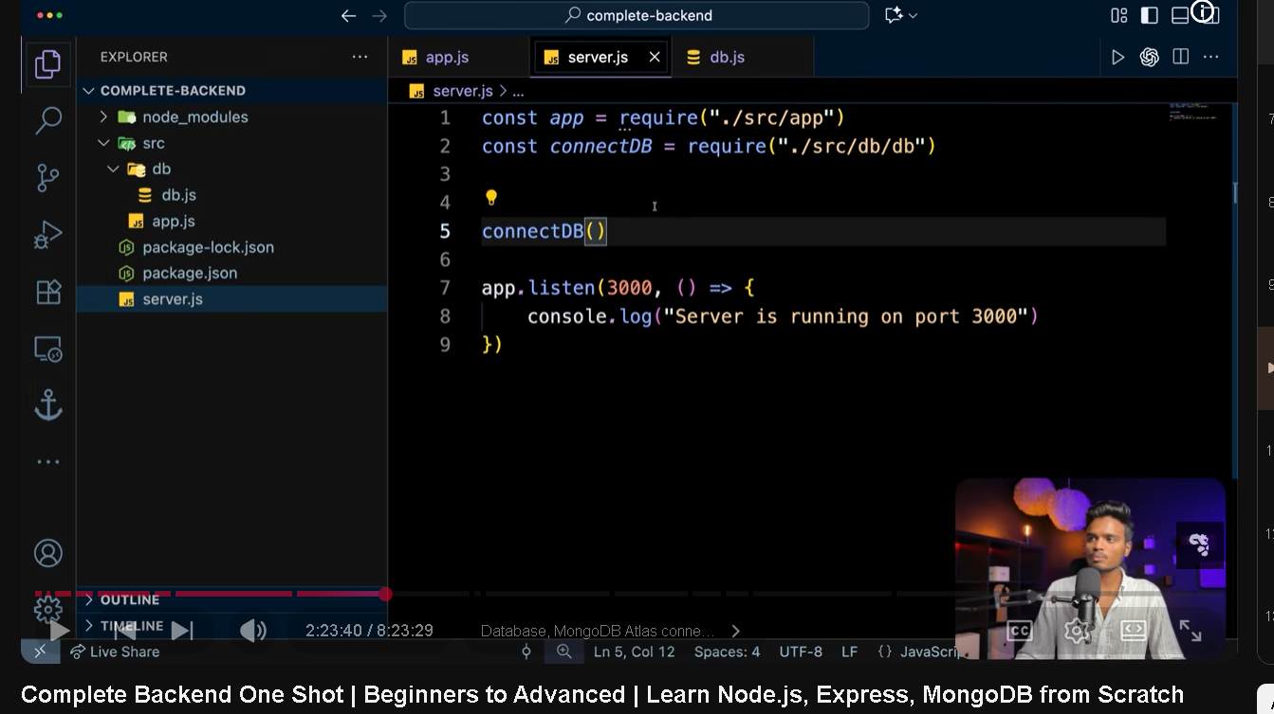
Db.js mai sari db connection ki logic likhnay kai add us db fucniton ko export kr kai server wali file mai impor kr kai db connection call kro gai to ho gaye database connection
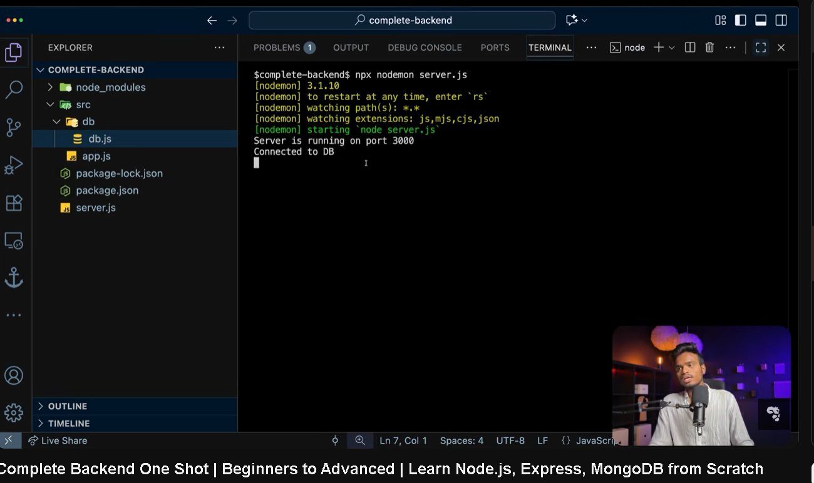
hamay data ko databse mai store krnay kai liye pehlay btana parta hai kai data kaisa dikhta hai scheme bna kai is kailiye ham src mai aik naya folder create krtay hai models kai name sai or phir models kai fodlers kai andar alag alag models schema jis ka bnana ho us ki files store krtay hai or phir us schema ko export kr kai require krtay hai app wali fiel mai ga kai kiu kai saray crud operatios kai routes wah defined krnay hai crud operation
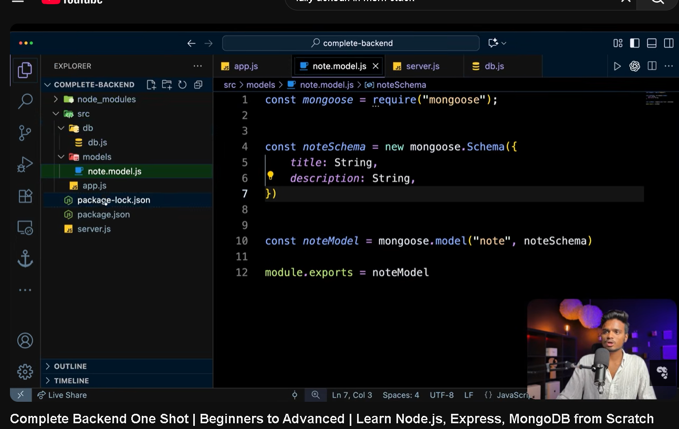
Wo go ham nai schema bna kai export kia hai wo schema use krtay hoay hai post request si front end sia go data aye ga usay create kr kai store krai gai mongo db mai

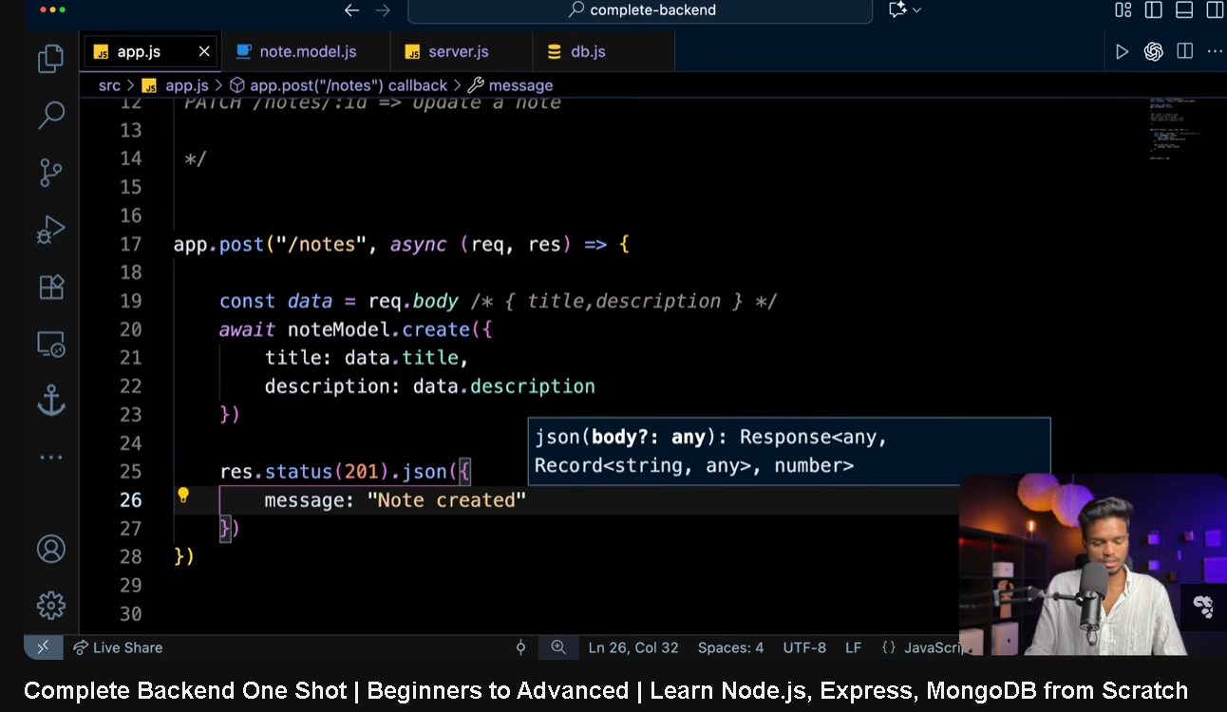
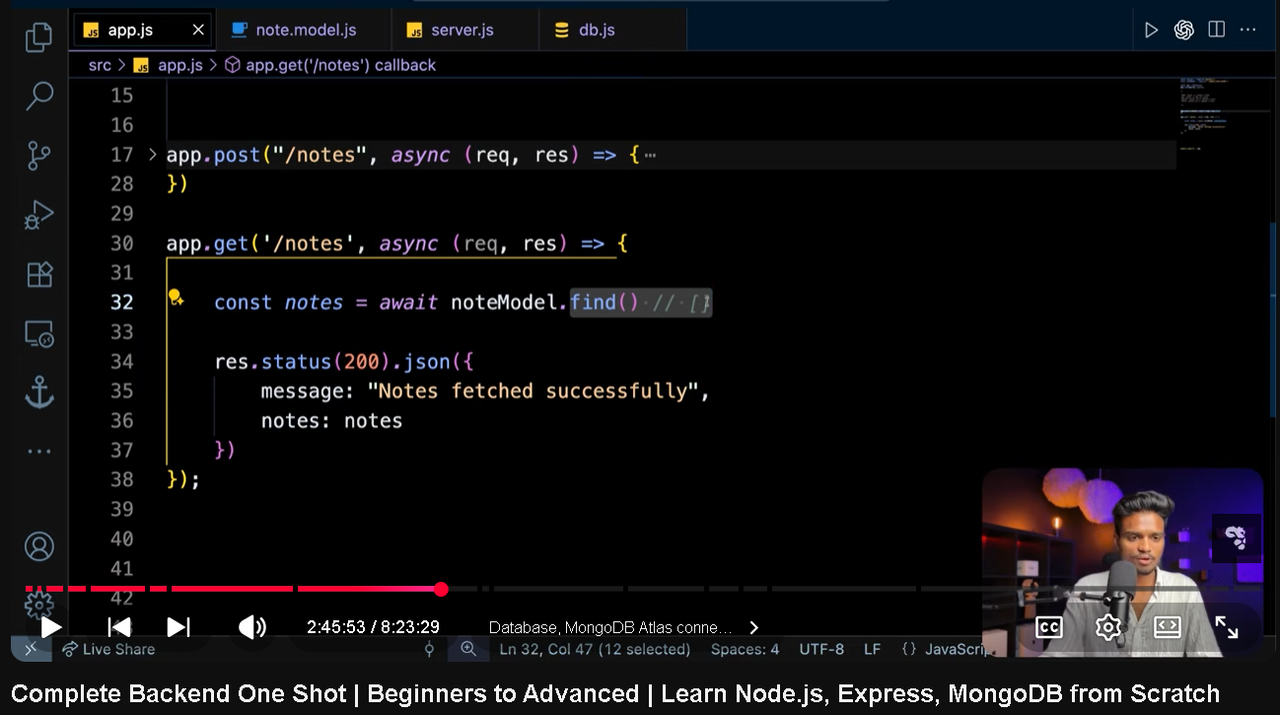
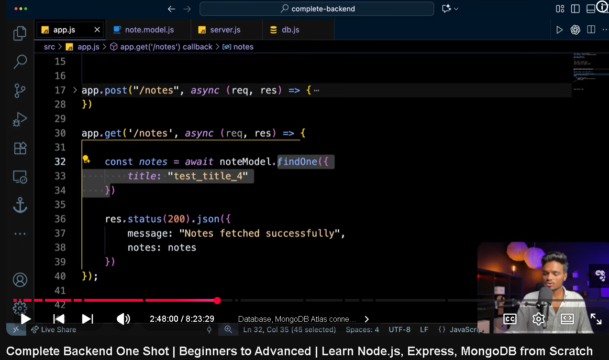
find object of array return krta hai saray or findone simple sirf aik objec data sai return krta hai

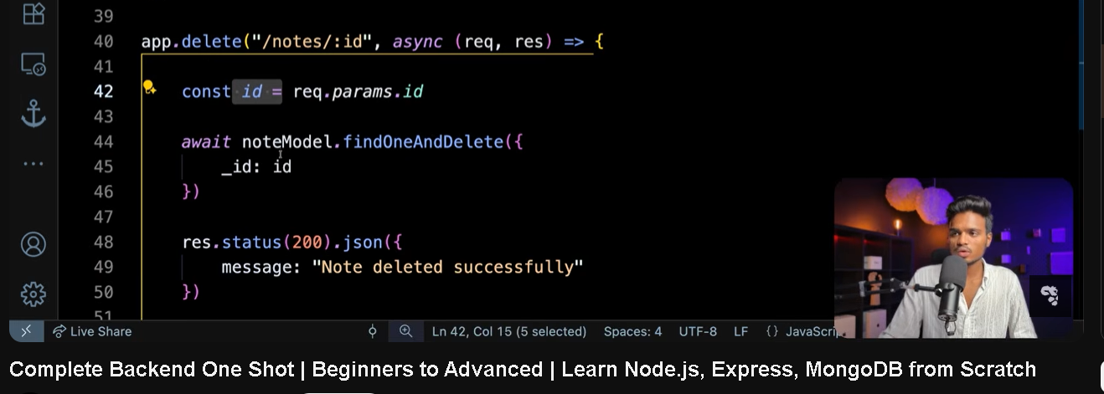
Find one and delete aik spceidc id ko delet krnay kai liye
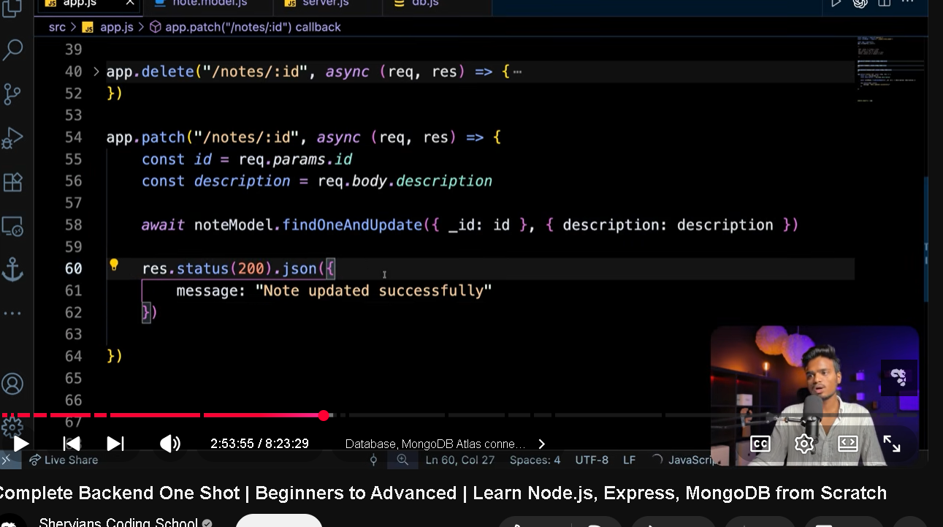
find one and update mai 2 param bhejnay hotay hai kon si id mai update krna wo id or kia update krna gaisay is mai descri[optn update kr rahay hai or id obviously parameters mai ati hai is liye param use kia hai or url mai go ati hai or description ham body mai daitay hai postman sai is liye body sai access kr rahay description
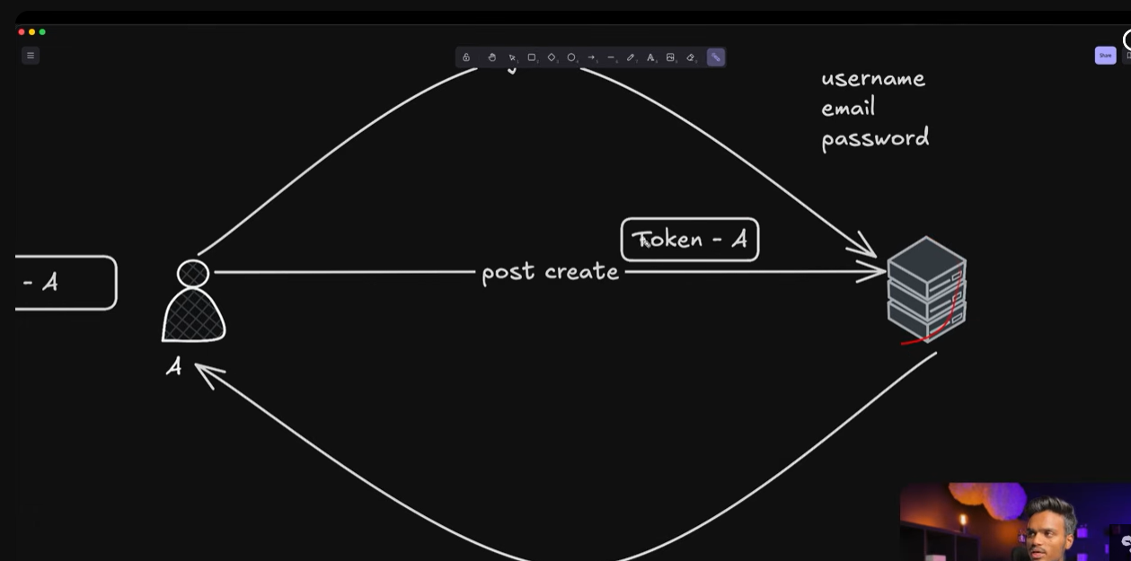
Src kai folder mai naya folder bnaye ai routes ka waha route end points bnaye gai
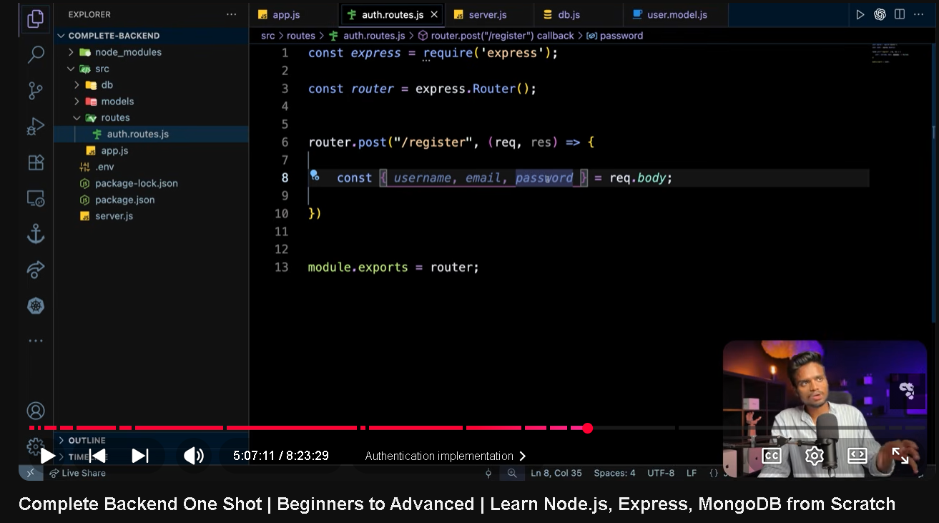
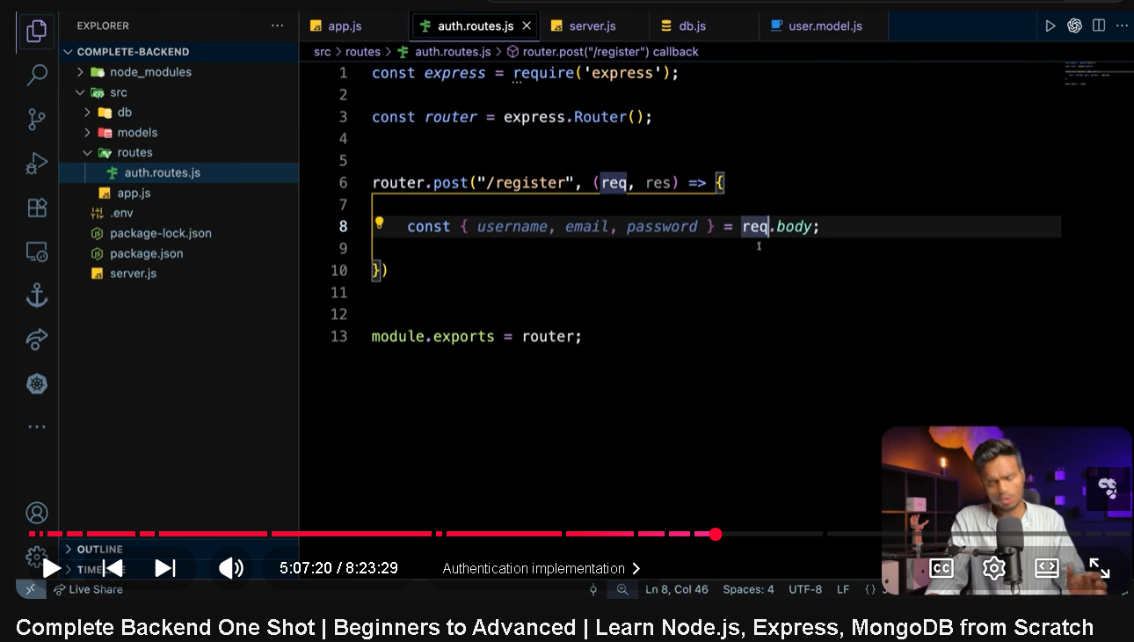
Routers mai sirf routers define krnay us kia logic ham controllers mai ga kai likhta hai
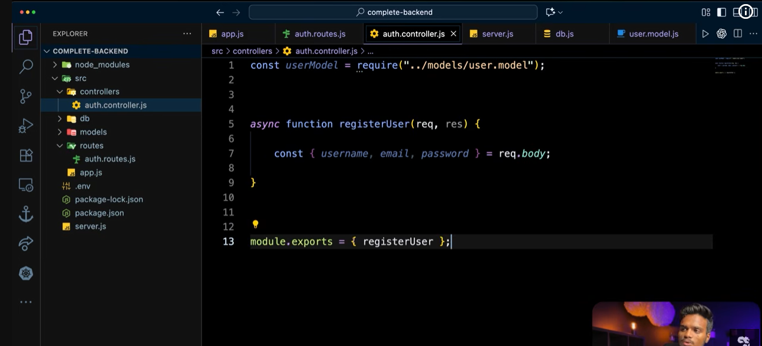
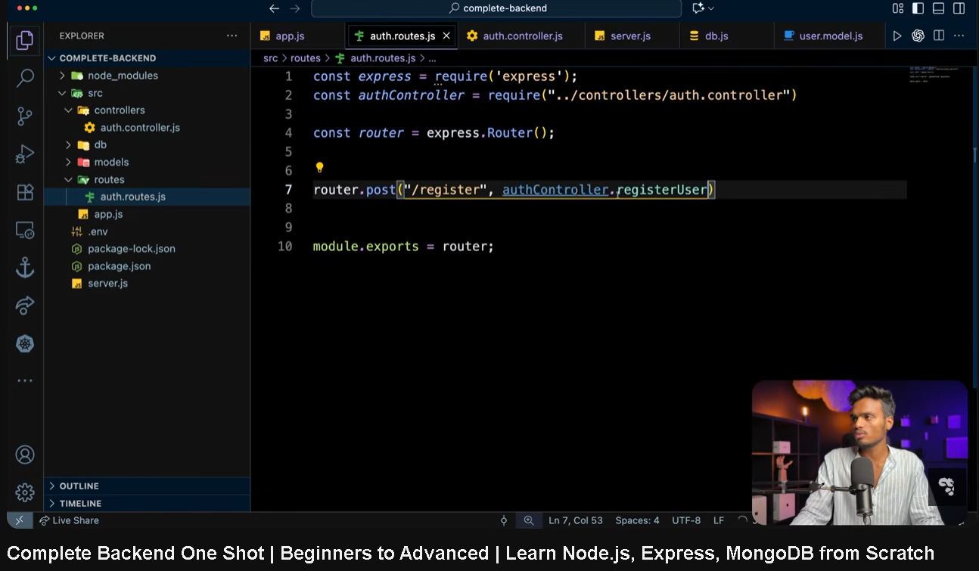
Routes kai andar sirf simple route bnao us ki functionality controllers way dolser mai likho phir export kr kai routes mai function attach kr do
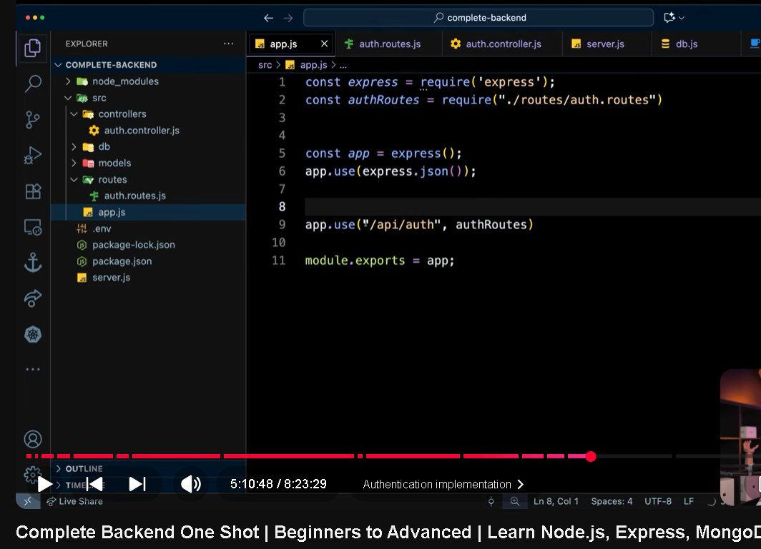
App.js mai maiga kai ham server kai saray apis key define krtay hai ta kai server ko pata chalay saray routes apis ka
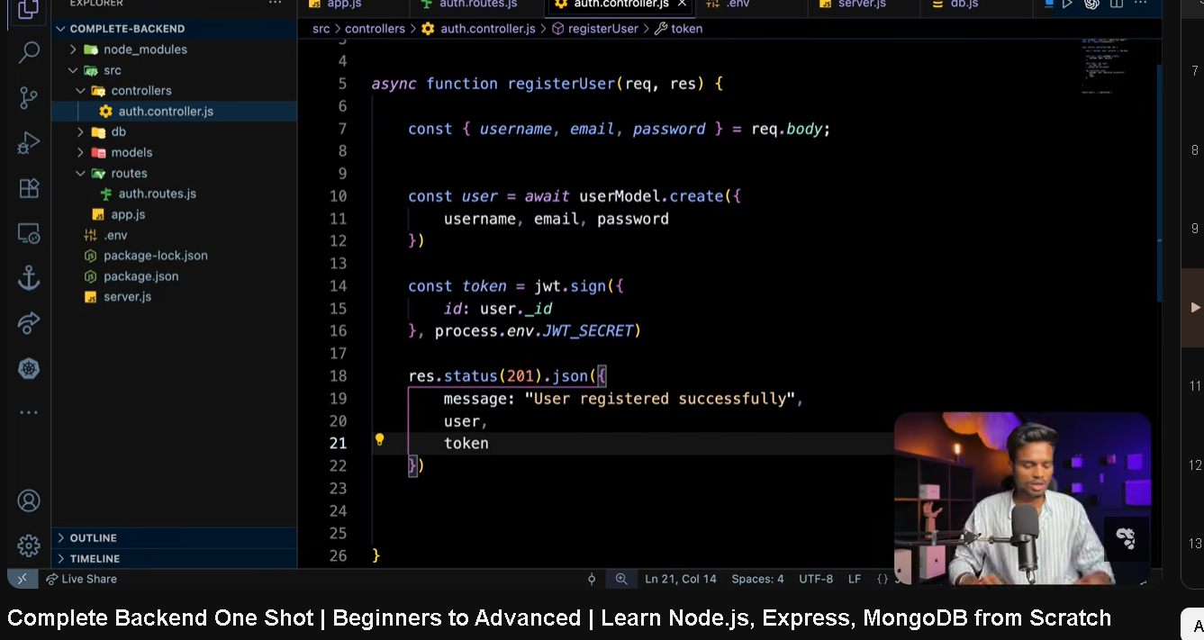
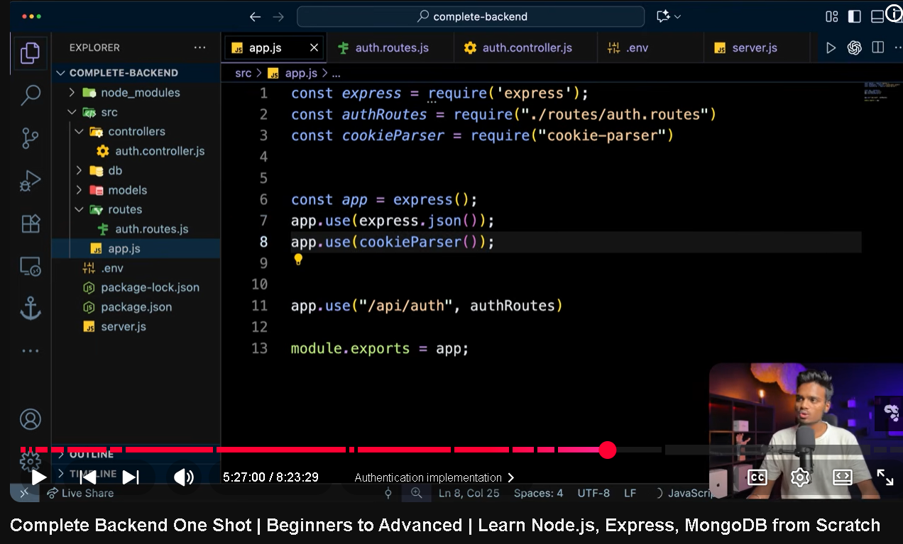
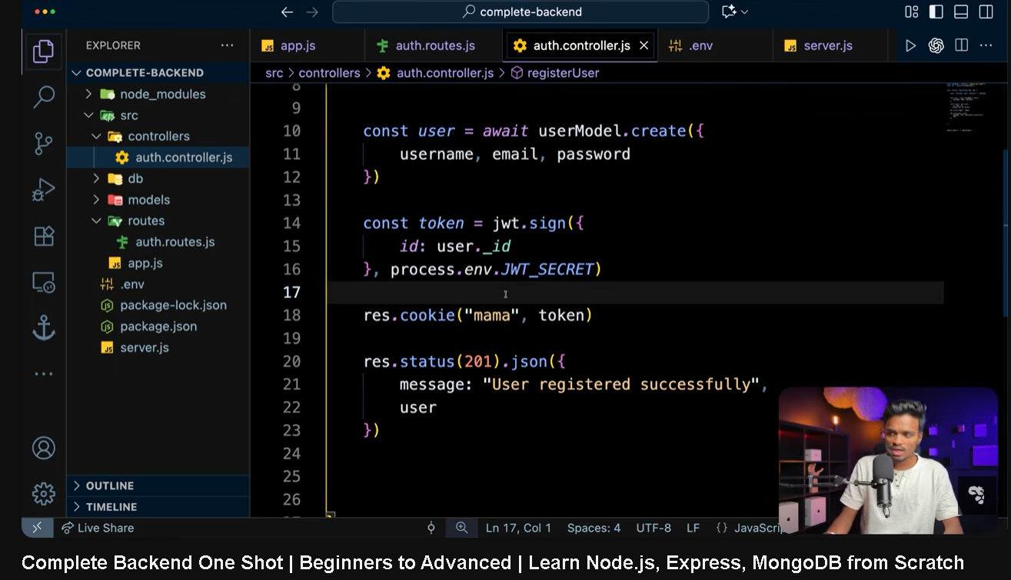
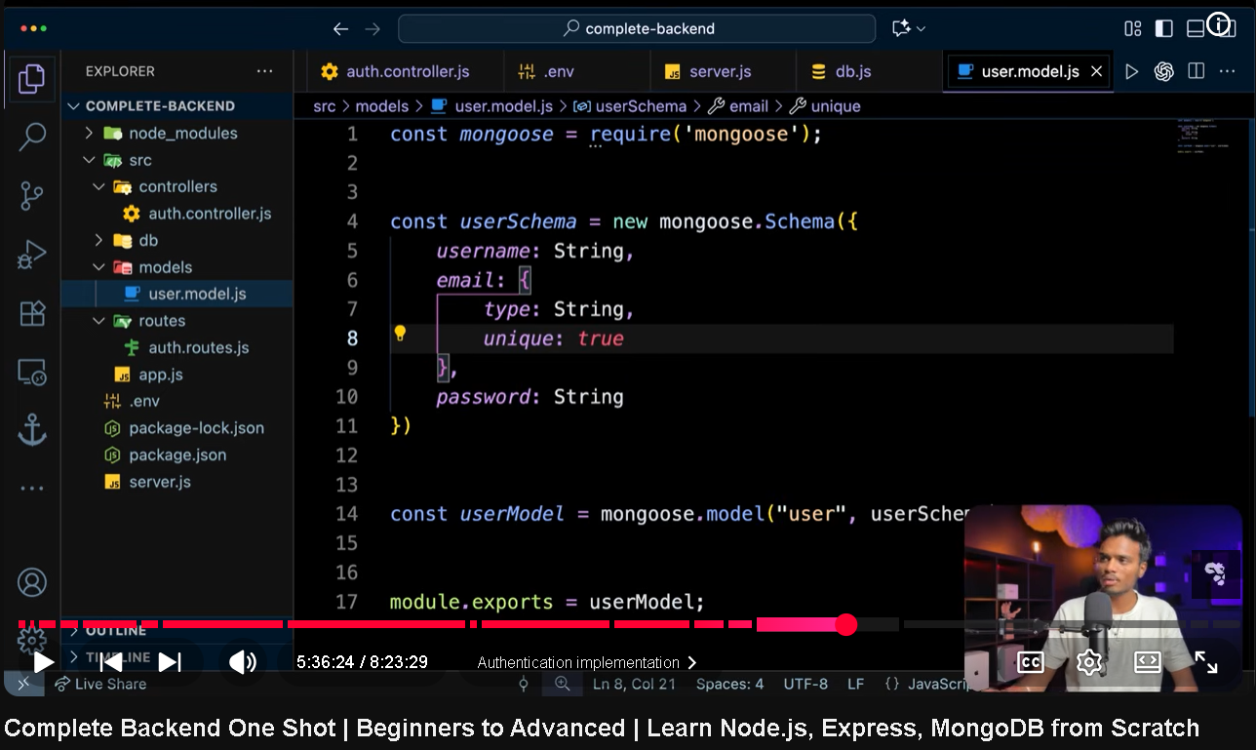
Schema kai andar unique email address bnanay sai unique bnany sai unique email address wala hi register
